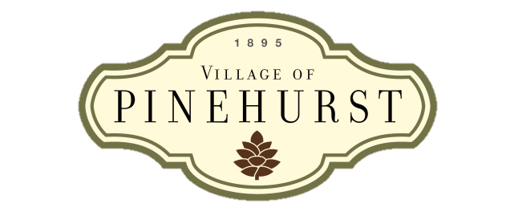**State of the Village Meeting**

Vision

The Village of Pinehurst is a charming, vibrant community which reflects our rich history and traditions, enhanced by a unique combination of cultural arts and recreational activities.

Mission

Preserve and enhance the community’s character and ambience by guiding growth, managing change, and providing services in a financially responsible manner.

Values

Competent

Courteous

Professional

Responsive

**Agenda**

**January 2014**

1. **Welcome**
   1. Purpose of SOV Meetings
   2. Introduce new employees
2. **Awards and Recognition**
3. **Legal and Ethical Behavior**
4. **Strategic Planning Update:**
   1. Council objectives & goals for FY 2015
   2. 2013 Community Survey results
5. **Initiatives:**
   1. Welcome Center/Public restrooms
   2. Single day solid waste collection
   3. 2014 US Open Championships
6. **Workplace Topics:**
   1. Performance management
   2. 2013 Workforce Survey results
   3. Wellness initiatives
   4. Employee safety
7. **Q&A**

