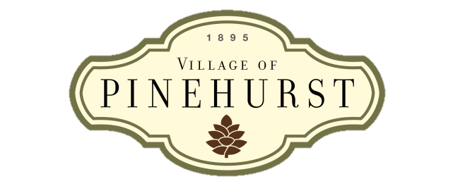**State of the Village Meeting**

**Vision**

The Village of Pinehurst is a charming, vibrant community which reflects our rich history and traditions, enhanced by a unique combination of cultural arts and recreational activities.

**Mission**

Preserve and enhance the community’s character and ambience by guiding growth, managing change, and providing services in a financially responsible manner.

**Values**

Competent

Courteous

Professional

Responsive

**Agenda**

**August 2014**

1. **Welcome** 
   1. Purpose of SOV Meetings
   2. Introduce new employees
2. **Awards and Recognition**
3. **Performance Excellence FY 2014 Update**
4. **FY 2015 Strategic Operating Plan**
   1. Balanced Scorecard
   2. Council Goals and Objectives
   3. Strategic Initiatives
   4. Budget and CIP
5. **Workplace Topics** 
   1. Employee Academy
   2. Pay and Classification Study
   3. Performance Management/emPerform
   4. Village Manager Search
6. **Legal and Ethical Behavior**
7. **Q&A**

