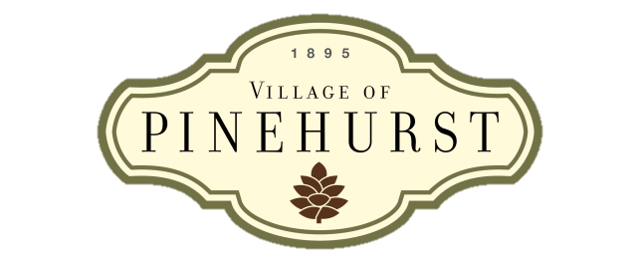**State of the Village Meeting**

Vision

The Village of Pinehurst is a charming, vibrant community which reflects our rich history and traditions, enhanced by a unique combination of cultural arts and recreational activities.

Mission

Preserve and enhance the community’s character and ambience by guiding growth, managing change, and providing services in a financially responsible manner.

Values

Accountable

Competent

Courteous

Professional

Resourceful

Responsible

Responsive

Trustworthy

**Agenda**

**August 2012**

1. **Welcome**
   1. Purpose of SOV Meetings
   2. Introduce new employees since January 2012
2. **New Village-wide Initiatives**
   1. Vision, Mission, and Values
   2. Branding/Logo Usage:
      1. Why the branding initiative
      2. Logo Usage Guidelines
      3. Standardization
   3. NC Awards for Excellence Program (NCAfE)– Performance Excellence Journey
      1. What is it? Overview of the “Baldrige Burger”
      2. Achieved Level 1/Working on Level 2
      3. Associated Initiatives
3. **Legal and Ethical Behavior**
4. **Other Initiatives**
   1. Village Center Enhancement Efforts
   2. Steam Plant Project
   3. Major Budgetary Items for FY 2013
5. **Workplace Topics**
6. **Q&A/Survey**

